HTML Elements

📘 Definition
# Source: AI Source: Provided by: [Data Path: Persons Table -> ID Column: 1, Name_En Column: Motasem Essam] -> From: [ChatGPT] on [5/6/2026]
HTML Elements are the building blocks of a web page. They define what each part of the content is, such as headings, paragraphs, images, or links.

🧱 What is an HTML Element?
# Source: AI Source: Provided by: [Data Path: Persons Table -> ID Column: 1, Name_En Column: Motasem Essam] -> From: [ChatGPT] on [5/6/2026]
An HTML element usually consists of:
- Opening tag
- Content
- Closing tag
An HTML tag is a special keyword used to define and structure content on a web page. Tags tell the browser how to display text, images, links, and more
Example:
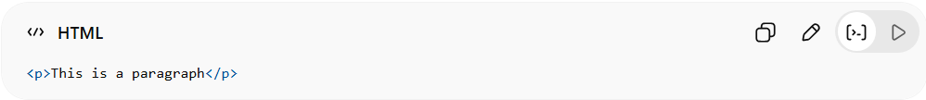
<p>This is a paragraph</p>
- <p> → opening tag
- This is a paragraph → content
- </p> → closing tag
👉 All of this together is called an HTML element.

🔹 More Examples of HTML Elements
# Source: AI Source: Provided by: [Data Path: Persons Table -> ID Column: 1, Name_En Column: Motasem Essam] -> From: [ChatGPT] on [5/6/2026]
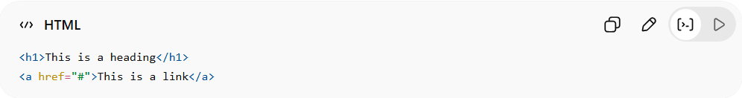
<h1>This is a heading</h1>
<a href="#">This is a link</a>
- <h1> → heading element
- <a> → link element

⚠️ Important Note
# Source: AI Source: Provided by: [Data Path: Persons Table -> ID Column: 1, Name_En Column: Motasem Essam] -> From: [ChatGPT] on [5/6/2026]
Some elements don’t have closing tags, called empty elements.
Example:
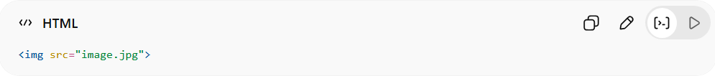
<img src="image.jpg">
- <img> displays an image
- No closing tag needed

🚀 In short:
# Source: AI Source: Provided by: [Data Path: Persons Table -> ID Column: 1, Name_En Column: Motasem Essam] -> From: [ChatGPT] on [5/6/2026]
HTML Elements = complete units made of tags + content that build a webpage.

